

Alberta Development Officers Association
Executive Meeting

Date: June 26, 2025
Time: 3:00 p.m.
Place: Virtual
Present: Jordan Ruegg President
Roger Garnett Vice-President
Diane Cloutier Treasurer/Conference Liaison
Steve Chipchase Membership Committee
Kristy Sidock Education Committee
Jenny Bruns Secretary
Diane Burtnick Executive Assistant, Active Member

Absent: Shanna Lee Simpson Communications Committee

AGENDA | ITEM | ACTION / MOTION
- Call to Order | 3:00 p.m. by Jordan Reugg.
- Additions to the Agenda | No additions were suggested.
- Treasurer/Conference Report | Kristy reported on the upcoming conference planning:  - Many moving parts with lots of people involved creating some logistics challenges.  - Working with hotel to bring costs down, remove any rooms not needed, as well as asking host municipalities for additional dollars.  - Request for additional dollars from the board will require formal request by August 1, 2025.  - Tourism Edmonton did not return calls regarding additional support.  - Tradeshow booths are just getting started. Will add revenue if booked.  - Discussed idea of gala versus dinner theater. Strong support in having gala and not losing that.  - Diane Burtnick will send email to Grant at Brokerlink to confirm $1500 sponsorship.  - Discussed steps to avoid in the future, such as minimum contribution and vetting municipalities for capacity ahead of time. Discussed covering cost of entertainment, helping with sponsorship ideas, and so on.  - Also discussed who might have administrative privileges to our LinkedIn account. Diane Burtnick will follow up on that.
- Next Meeting | At call of the chair.
12) Adjournment | Board adjourned at 3:52 p.m. | Motion to adjourn at 3:52 p.m. by Kristy Sidock.  CARRIED

______________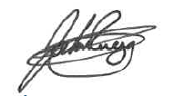_____________ _September 2, 2025_________
President Date
__________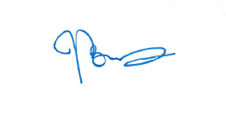______________ _September 2, 2025_________
Secretary Date

